COGO/FALL 2015 Names: _____________________________________ Political Parties: ___________________
Unit 2: UK & EU
UK Political Party Presentations

Directions: You will be assigned two of the British political parties to research. You will be responsible for researching, creating & presenting a mini-slideshow based on the rubric below.
RUBRIC:

- _____ (10pts) 7-10 Slides, Limited Text (simplify information and put in easiest terms – do NOT just copy & paste from
website!)
- _____ (10pts) Explain the party’s ideology (include where they fall on the political spectrum)
- _____ (10pts) Look up the party’s manifesto and outline the main policy positions (Hit main points – keep
text limited)
- _____ (10pts) Identify current leaders (do they serve important positions in the current Parliament? Note: some parties
may still be choosing a leader after the resignations that followed the 2015 general election)
- _____ (10pts) Identify main supporters (certain economic classes? certain regions? certain gender/race?)
- _____ (10pts) Indicate how many members they have in Parliament (regional & national)
- _____ (10pts) Is this party growing or declining in power? Results in 2015 General Election?
- _____ (10pts) Show graphics of campaign posters, party slogans, key leaders, etc
- _____ (20pts) Presentation of slideshow demonstrates knowledge and understanding and not just
“reading” of slides
_____ (50pts) TOTAL

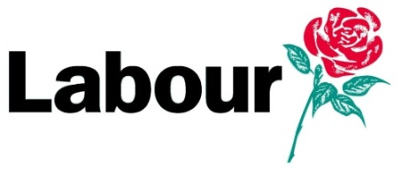
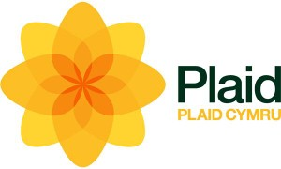
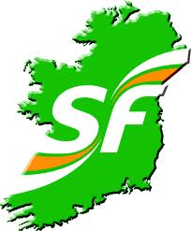

*Conservative
*Liberal Democrat
*Labour
*UK Independence Party (Ukip)
*Scottish National Party (SNP)
*Democratic Unionist Party
Plaid Cymru
Sinn Féin
Green

