AP COGO: Mexico Name(s): ______________________________________
Electoral Comparison: Russia vs. Mexico
Essential Question: Is Mexico’s Past, Russia’s Future?

Directions: Use the electoral data provided to answer the questions below. You may also need to consult your book or notes for background information.

Russian Electoral Questions:

1. In the Duma elections since the fall of communism, what is the trend in support for the Communist Party? What might account for the changing support the Communist Party receives in Duma elections?

2. What has happened to the number of parties gathering more than 10% of the overall vote in the Duma elections? How do you account for this?

3. What changes have been made in the way the Duma is elected? Why is it harder for smaller parties to capture seats?

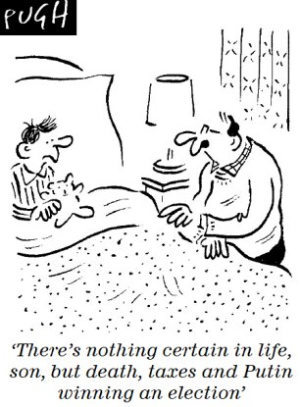

4. How many presidential candidates captured more than 5 percent in each election shown?

5. What was the gap between Putin and his closest competitor in the 2004 election? The 2012 election?

6. What trends can be seen in Russian presidential elections? What might account for these trends?

7. Based on the data, is Russia becoming more or less democratic? Identify and explain two reasons for your answer.

Mexican Electoral Questions:

1. Describe one trend in the table titled “Voting in Mexican Presidential Elections, 1934-2000.” What factors might account for this trend?

2. What is the relationship between voter turnout and the percent of the vote received by the PRI in each presidential election? Does this demonstrate causation or correlation?

3. In which presidential election was there the first significant challenge to PRI control? Support your answer with data.

4. Using the 2006 & 2012 Chamber of Deputies and Senate results and your knowledge about the 2006 and 2012 presidential elections, discuss the relationship between the executive and legislative branches on the Mexican government. How is this different from previous administrations in the Mexican government?

5. Has the loss of PRI control been a positive development for the Mexican people? Why or why not?

6. Based on the data, is Mexico becoming more or less democratic? Identify and explain two reasons for your answer.

Comparative Questions:

1. Using your background knowledge and information from your text, briefly explain how the PRI stayed in power.

2. How did the electoral system in Mexico reinforce one-party rule? What are the similarities and differences to the electoral system in Russia?

3. Using your background knowledge and information in your text, briefly explain how institutional changes made Mexico more democratic.

4. How are current Russian institutions used to consolidate authority?

5. Is Russia or Mexico closer to being a true multiparty system? Identify and explain two reasons for your response.

6. Is Mexico’s past Russia’s future? In other words, is Russia become a one-party system similar to Mexico under PRI control? Why or Why not?

