BIG IDEA
Starting in 1763, the American colonists, having enjoyed a long period of “salutary neglect*,” resisted British attempts to impose tighter imperial controls and higher taxes after the French and Indian War. After twelve years of increased tensions between the colonies and the mother country, the military engagement at Lexington and Concord in 1775 ignited the American Revolution.
*The policy was an intentional lack of enforcement by the British government of British trade laws in the American colonies.

1754 – 1763
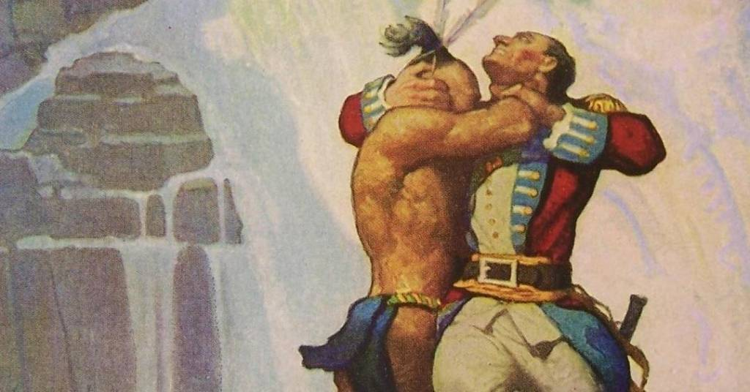
The French and Indian War began between the English and French over land in the Ohio River Valley. Colonists fought for England. The English won the war, but the war left them in debt and needing money. England looked at the colonies as a source of money and it led to a series of actions by King George and the English legislature, called Parliament that angered the colonists. In October of 1763, through the Proclamation of 1763, England banned colonists from settling west of the Appalachian Mountains.

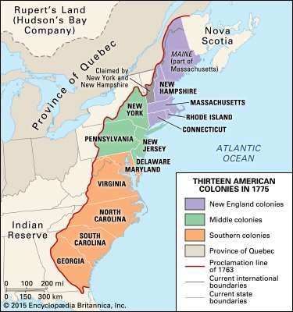

Near the end of the war, English officials were given search warrants that allowed them to search warehouses, homes, and ships of colonists without a reason. A colonist and Boston lawyer, James Otis decided to challenge whether or not the warrants were legal in court. He argued that they violated the individual rights of the colonists.

1764
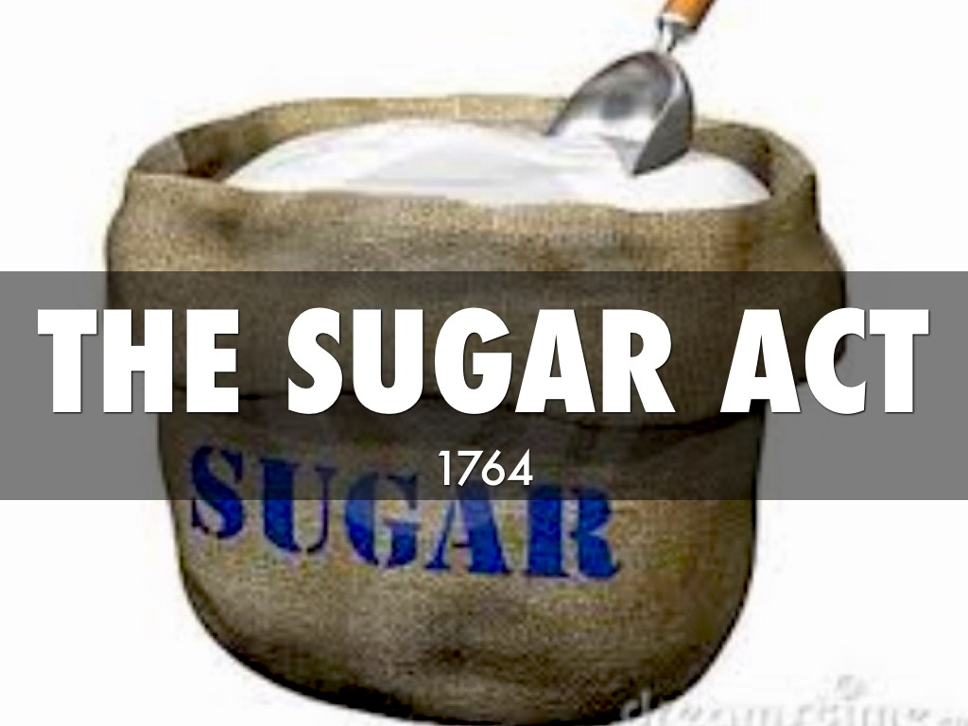

In April of 1764 Parliament taxed sugar that was imported, or brought into the colonies, to pay off the war debt and to help pay for the expenses of running the colonies. This act increased the duties, or taxes, on imported sugar and other items such as textiles, coffee, wines and indigo (dye). In response to this, Boston businesses start boycotting some English goods.
In the fall of 1764, Parliament ordered colonies to stop printing their own money. Colonists opposed the order because they feared it would upset the economy.
Currency Act of 1764 restricted colonial printing of paper money. Wanted the colonists to pay back debts (and pay taxes) with gold or silver. This was in an effort to control the money supply and reduce inflation.
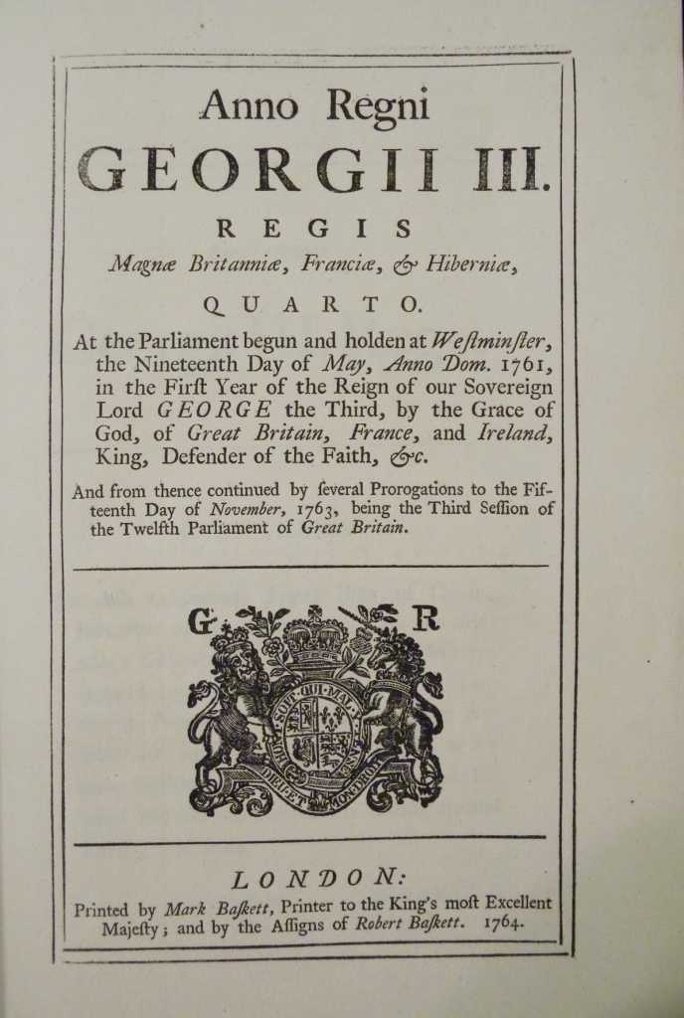

1765
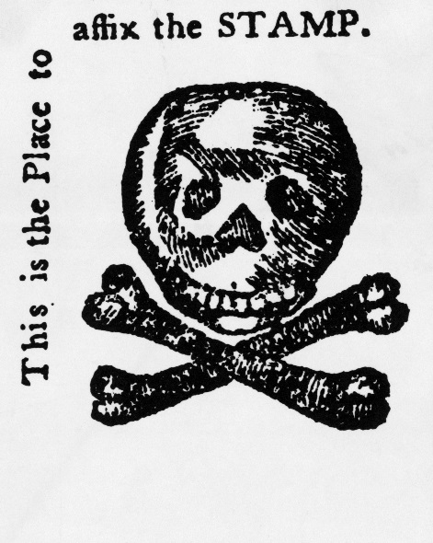
In March of 1765, Parliament passed the Stamp Act. Under the Stamp Act, all printed materials were taxed, including; newspapers, pamphlets, bills, legal documents, licenses, almanacs, dice and playing cards. The money collected from the tax did not go to colonial legislatures but directly to England. Later on in the same month, Parliament ordered colonial legislatures to pay for English soldiers that are located in the colonies. It also required colonists to house British troops and supply them food.
In May, Patrick Henry, a colonist, gave a speech to the Virginia legislature saying that only the Virginia legislature, not Parliament, can tax Virginians. In July, a secret group of colonists called the Sons of Liberty formed in some towns. They were opposed to the Stamp Act and they used violence and intimidation to force all of the English stamp agents to resign. They also stopped many colonists from ordering English goods. In the fall, representatives from nine of the colonies met in New York and prepared a petition to be sent to King George III and Parliament. The petition requested that the Stamp Act and the Acts of 1764 stop being enforced. The petition stated that only colonial legislatures can tax colonists and that taxation without representation violated the colonists' basic civil rights. Below is an excerpt from Patrick Henry’s his speech.
“We can under law be taxed only by our own representatives. We have no representatives in the British Parliament. So how can the British Parliament place this tax on us? It is simple; they cannot! The Stamp Act is against the law. We must not obey it… King George is a tyrant. He breaks the laws. He is an enemy of his own people.”
- Speech by Patrick Henry to the Virginia House of Burgesses, May 1765 in response to the Stamp Act
Colonist were not opposed to taxes but they thought the colonial governments should tax, not Britain. NO Taxation without Representation was the idea that Colonists had no representation in British Parliament - their rights as British citizens were being denied.
Lord Grenville’s response: colonies had virtual representation in Parliament -- All British subjects were represented, even those who did not vote for members in Parliament.
Reactions to the Stamp Act
Protest against the Stamp Act led to:
- Mob Riots: Tax collectors resigned which made the stamp tax impossible to collect
- Boycotting British Goods: “Save your money and you can save your country”
- The boycott mobilized women who were in charge of the home and dictated what families bought [The Daughters of Liberty]
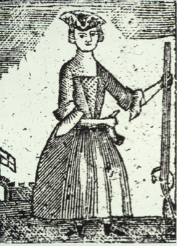
Woodcut of a Daughter of Liberty during the Revolutionary War

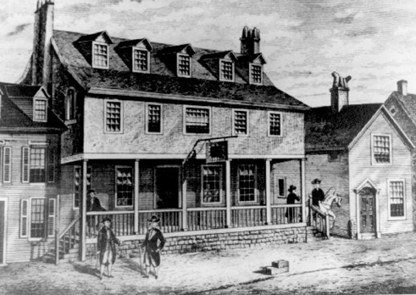
1765
In 1765, the British sent 40,000 soldiers to the colonies to help collect taxes from the colonists. The Quartering Act forced colonists to provide British troops with living quarters, food, and supplies.

The British Parliament told some American colonists that they must let the soldiers live in their homes. Many colonists had strong feelings about this new British law and the overwhelming presence of British troops. In the colony of New York, which was the headquarters for the British Army, distrust of the British soldiers grew.

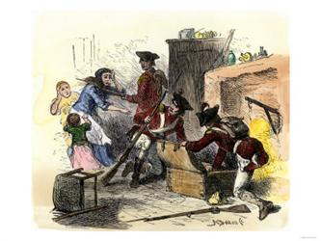

1766-1768
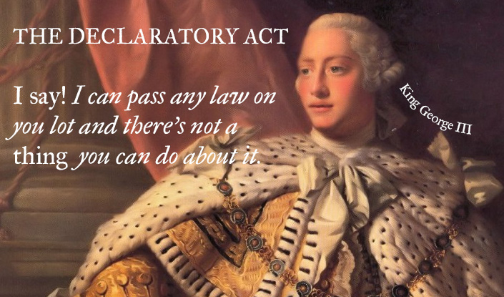
In March of 1766, Parliament ended the Stamp Act, but it also passed the Declaratory Act. This act stated that England had total power to legislate any laws governing the colonies. In the summer of 1767, Parliament passed the Townshend Revenue Act. This act taxed many items imported into the colonies, such as: paper, tea, glass, lead and paints. In response, colonists decide to refuse to purchase, or boycott, some of these items. The Townshend Acts created a Board of Customs Commissioners to collect taxes. Ordered NY Royal Governor to veto all laws by the colonial assembly until the Quartering Act was obeyed.
In February of 1768, Samuel Adams from Massachusetts wrote a letter against taxation without representation, the idea that it is unfair to tax someone without giving them representation in government, and called for resistance to the Townshend Act. He encouraged other colonies to support the letter. In September, English ships sail into Boston Harbor and English troops set up permanent residence in Boston to keep order. In 1769, Philadelphia businesses join the boycott against British goods. Later in the year, New Jersey, Rhode Island, North Carolina also joins the boycott.
Response to the Townshend Acts
- The Sons of Liberty organize another boycott of British goods
- Women become more active in opposing British policies - reduce consumption of foreign goods / make goods at home [homespun cloth]. Daughters of Liberty
- Massachusetts Assembly circulates a letter written by Sam Adams arguing that this law violated the natural rights of colonists, who - should be able to tax themselves.
- British government considers this letter to be an “act of treason” and dissolves the Massachusetts Assembly. British troops sent to Boston to put down riots that erupted after this decision.

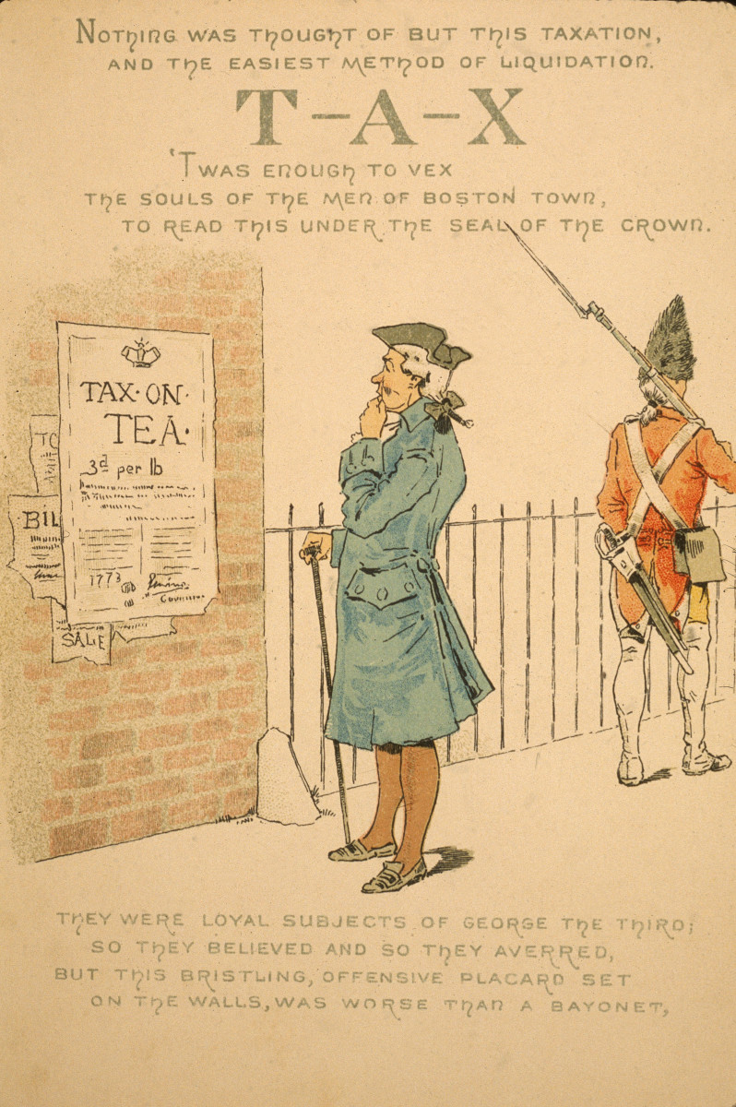
1770
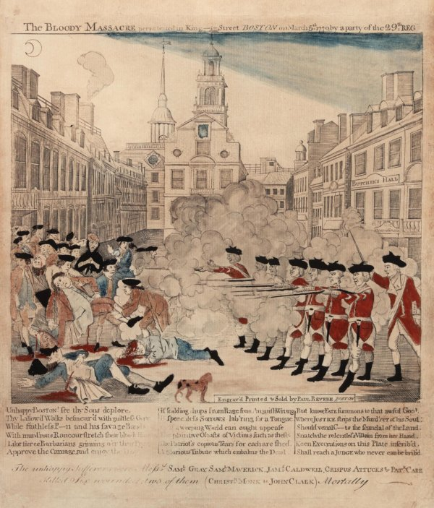
Paul Revere, “The Bloody Massacre in King-Street, March 5, 1770.” Boston, 1770.

In March of 1770, the Boston Massacre happened. This event occurred when a large crowd of colonists crowded around and harassed English soldiers. In response, the soldiers fired their guns into the crowd killing five people and injuring six. After the incident, the troops are withdrawn out of Boston. The same day as the Boston Massacre, Parliament ended all taxes on imports except for tea.
“Drowne saw Captain Preston, whom he knew well, with a number of soldiers armed with guns near the Custom House. Drowne believed that most of the crowd left after seeing the armed soldiers. No more than twenty or thirty remained on King Street. Those who remained were mostly sailors and other persons who were poorly dressed. Several of them dared the soldiers to fire. Drowne then heard Capt. Preston say to the soldiers, “Damn your bloods! Why don't you fire?” The soldiers did not listen and Preston immediately said “Fire.” The soldiers fired randomly.”
- Summary of the sworn testimony of Samuel Drowne, March 16, 1770.

“The soldiers were attacked by a great number of heavy clubs and snowballs were thrown at them. All our lives were in danger. At the same time, someone from behind called out, “Damn your bloods — why don't you fire?” Instantly three or four of the soldiers fired and then three more fired in the same confusion. The mob then ran away, except three unhappy men who instantly died. When I asked the soldiers why they fired without orders, they said they heard the word fire and thought it came from me. This might be the case as many of the mob called out fire, but I told the men that I gave no such order. My words were, don't fire, stop your firing.”
- Source: The Case of Capt. Preston of the 29th Regiment, Public Advertiser (London), April 28, 1770

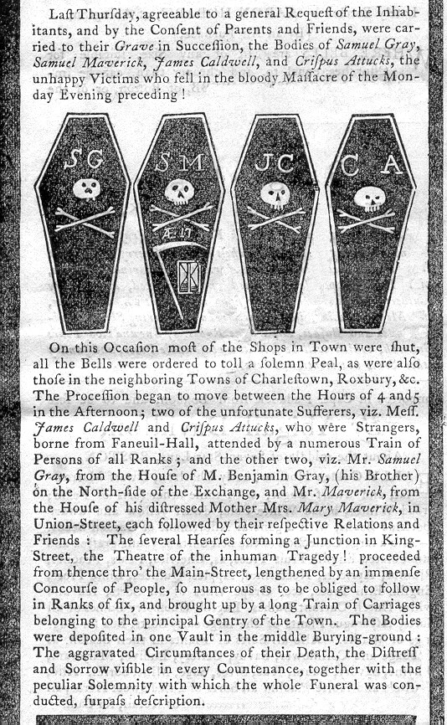

1773
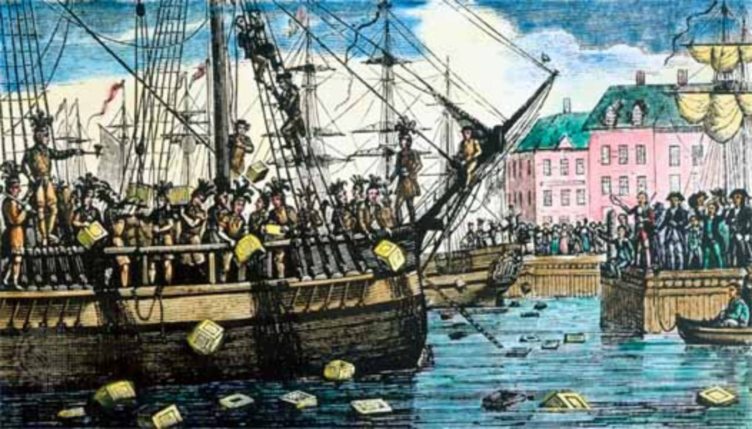
In May of 1773 Parliament made the British East India Company the only company allowed to import tea into the colonies. This is called the Tea Act. Months later, in response to the Tea Act, a group of colonists board English ships in Boston, and dump hundreds of chests of tea into the harbor. This becomes known as the Boston Tea Party.
In response to the Boston Tea Party, Parliament passed a series of laws. Colonists call them the Intolerable Acts. The first of the acts closed the port of Boston until all the damage caused by the Tea Party is paid back. The English also put Massachusetts under military rule and more troops arrived in the colony. The second of the acts made it illegal for royal officials to be brought to trial in the colonies. Instead, their trials were held in England. The third act ended the colonial government in Massachusetts and instead allowed the royal governor to appoint the colonial legislature. The fourth act ordered colonists to house troops, even in colonists’ homes. In the fifth and final act, Parliament gave land claimed by Massachusetts, Connecticut, and Virginia to Canada.

“The tea destroyed was contained in three ships, lying near each other at … Griffin's wharf, and were surrounded by armed ships of war…

It was now evening, and I immediately dressed myself in the costume of an Indian, equipped with a small hatchet… and a club, after having painted my face and hands with coal dust in the shop of a blacksmith, I repaired to Griffin's wharf, where the ships lay that contained the tea. When I first appeared in the street after being thus disguised, I fell in with many who were dressed, equipped and painted as I was, and who fell in with me and marched in order to the place of our destination.

When we arrived at the wharf,… they divided us into three parties, for the purpose of boarding the three ships which contained the tea ... as soon as we were on board the ship … [they] ordered me to go to the captain and demand of him the keys to the hatches and a dozen candles. I made the demand accordingly, and the captain promptly replied, and delivered the articles; but requested me at the same time to do no damage to the ship or rigging. We then were ordered by our commander to open the hatches and take out all the chests of tea and throw them overboard, and we immediately proceeded … first cutting and splitting the chests with our tomahawks, so as thoroughly to expose them to the effects of the water.

In about three hours from the time we went on board, we had thus broken and thrown overboard every tea chest to be found in the ship, while those in the other ships were disposing of the tea in the same way, at the same time. We were surrounded by British armed ships, but no attempt was made to resist us…”
- George Hewes, An Eyewitness Account of the Boston Tea Party (1773)

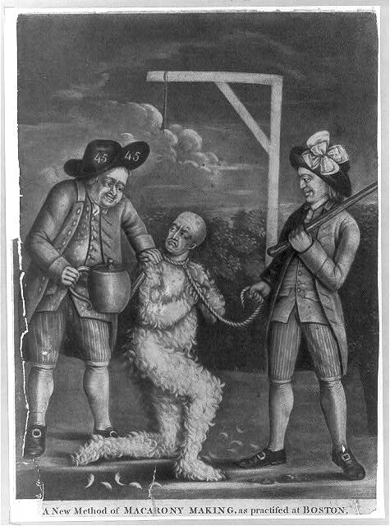
“A New Method of Macarony Making, as Practised at Boston,” print, circa 1774. Print shows two men tarring and feathering a British customs officer and forcing him to drink tea. The man holding the teapot is wearing a hat with number 45 on it, a symbol referring to the John Wilkes case of 1763. The other man is holding a noose and carrying a club. The large bow in his hat indicates his membership in the Sons of Liberty.

1774-1775
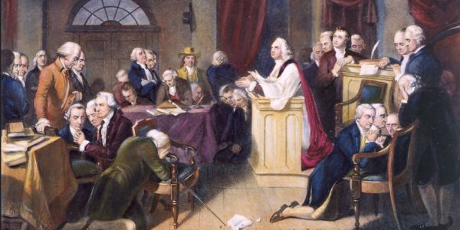
In response to these acts, the First Continental Congress met in September 1774 in Philadelphia. Every colony, except Georgia, sent representatives. The Congress declared that these acts should not be obeyed and they began forming militias in the colonies. The Congress agreed to boycott English imports and to stop exporting goods to England.

In early 1775, Massachusetts began forming militia units and Parliament declared the colony to be in a state of rebellion. A month later, King George passed an act ordering the New England (Connecticut, Massachusetts, New Hampshire and Rhode Island) colonies to trade only with England.

1775 Cont…

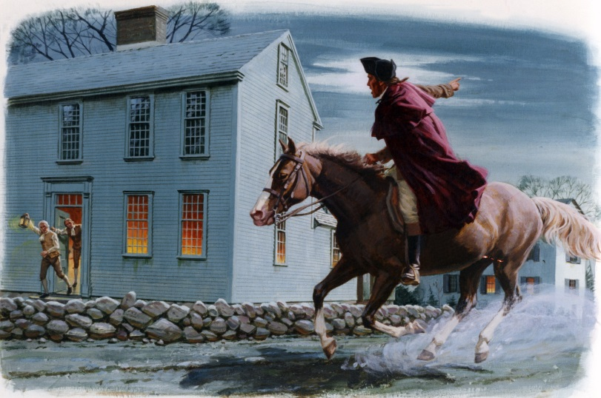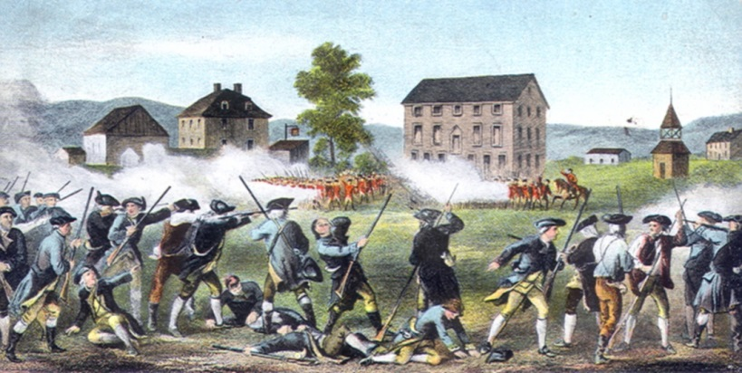

On April 18 1775, Paul Revere rode from Boston to warn colonists that English troops were coming to take weapons away from the colonists. The following day, on April 19, both sides begin fighting at Lexington and Concord in Massachusetts. This is the first battle of the Revolutionary War and is referred to as “the shot heard ‘round the world.”
“19th. At 2 o’clock we began our march by wading through a very long stream up to our middles. About 5 miles away from a town called Lexington, we heard there were some hundreds of people collected together intending to oppose us. At 5 o’clock we arrived there and saw a number of people, I believe between 200 and 300, formed in a common in the middle of the town. We still continued advancing, keeping prepared against an attack though without intending to attack them. As we came near them, they fired one or two shots, upon which our men without any orders, fired and put them to flight. We then formed on the Common, but with some difficulty, the men were so wild they could hear no orders; we waited a considerable time there, and at length proceeded on our way to Concord.”
Source: Entry for April 19, 1775, from the diary of Lieutenant John Barker, an officer in the British army.
“We Nathaniel Mulliken, Philip Russell, (Followed by the names of 32 other men present on Lexington Green on April 19, 1775) . . . all of lawful age, and inhabitants of Lexington . . . do testify and declare, that on the nineteenth of April, about five o’clock in the morning, we proceeded towards the Green, and saw a large body of troops marching towards us. Some of our men were coming to the Green, and others had reached it, at which time, they began to disperse. While our backs were turned on the British troops, they fired on us, and a number of our men were instantly killed and wounded, not a gun was fired by any person in our company on the British soldiers to our knowledge before they fired on us, and continued firing until we had all made our escape. Lexington, April 25, 1775.”
Source: Sworn by 34 minutemen on April 25, 1775, before three justices of the peace.

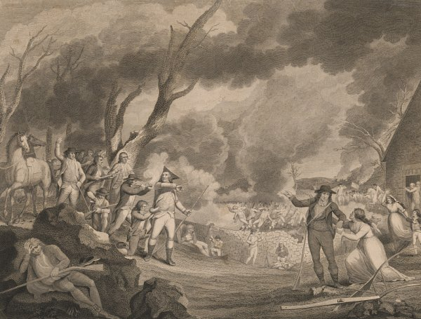
Image: Engraving of the Battle of Lexington made by Cornelius Tiebout in the 1790s. From the Library of Congress.
1775 Cont…
The following month, the Second Continental Congress met in Philadelphia. The Congress named George Washington as the commander in chief of the Continental (colonial) Army.
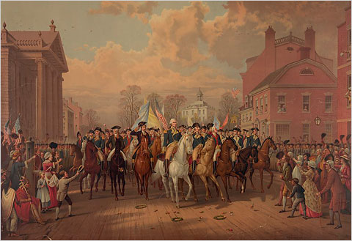
On June 17th, the first major battle, the Battle of Bunker Hill, occurred between the English and colonial troops. England won the battle.
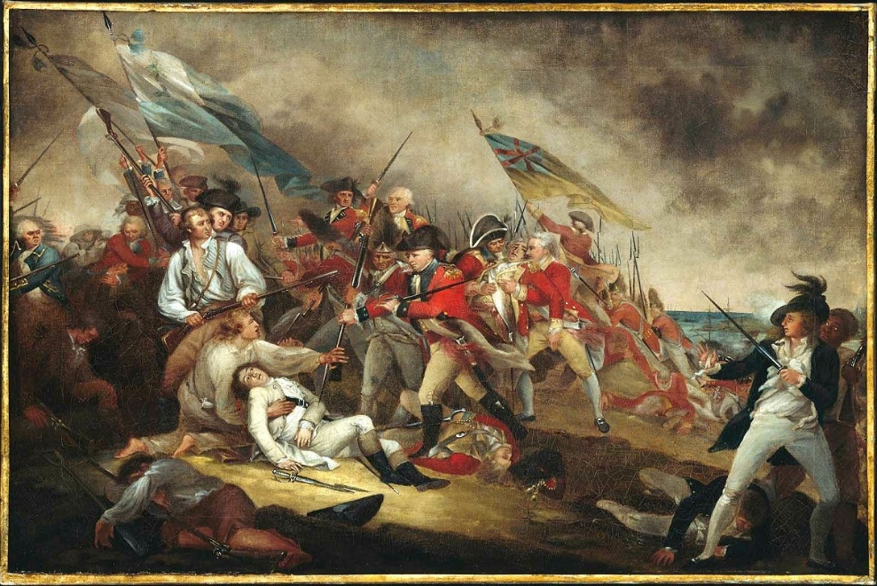
John Trumball's The Death of General Warren at the Battle of Bunker's Hill, 17 June, 1775. (Museum of Fine Arts, Boston)

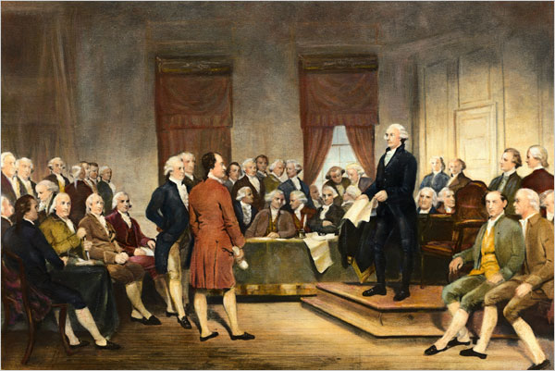
After the battle, the Second Continental Congress sent a petition to King George asking him to reach an agreement with the colonists so that fighting does not have to continue. The King refused to read the petition. Instead King George proclaimed that the colonists were rebelling and he ordered troops to end the rebellion. In addition, Parliament ordered an end to colonial trade.
An excerpt from the Olive Branch Petition:
To the King's Most Excellent Majesty. Most Gracious Sovereign,
We your Majesty's faithful subjects of the colonies…, in behalf of ourselves and the inhabitants of these colonies, who have deputed us to represent them in general Congress, entreat your Majesty’s gracious attention to this our humble petition.
The union between our Mother Country and these colonies, and the energy of mild and just government, produced benefits so remarkably important, and afforded such an assurance of their permanency and increase, that the wonder and envy of other Nations were excited, while they beheld Great Britain rising to a power the most extraordinary the world had ever known.
That your Majesty may enjoy a long and prosperous reign, and that your descendants may govern your dominions with honor to themselves and happiness to their subjects is our sincere and fervent prayer.
The Kings’ Reaction to the Olive Branch Petition:
The Second Continental Congress was still in session when they received King George III's reaction to the petition. Important founding fathers including John Adams, Thomas Jefferson, and Ben Franklin listened intently as John Hancock read the King's response aloud to the congress.
The King rejected the petition, refusing to read it because in his mind it was an illegal document made by an illegal congress. Not only did the King reject the colonists attempt at peace, but he announced new measures to punish the colonies. He declared that all British ships stop American ships from leaving their ports. He also hired Hessians, or German soldiers, to fight in America against the colonists.
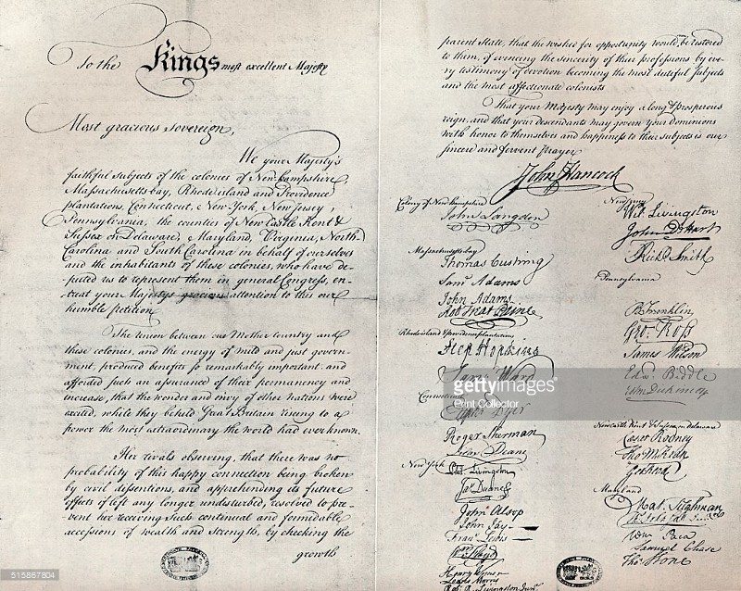
Olive Branch Petition, 1775. And Nsignature Page Of The 'Olive Branch Petition,' Adopted By The Continental Congress In July 1775, To Prevent Further Conflict With Great Britain
1776
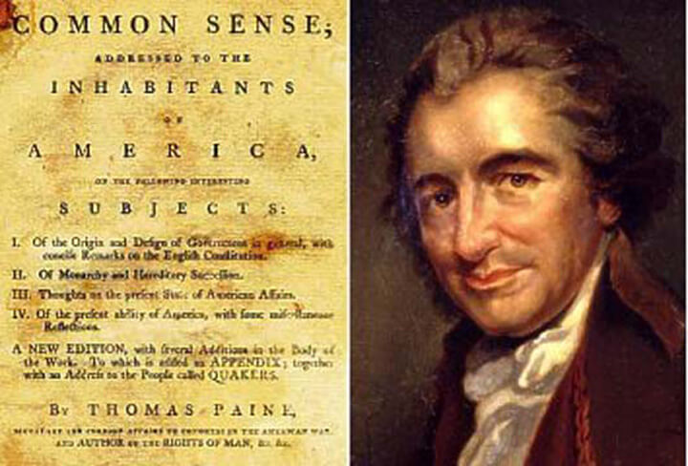
In January of 1776 Thomas Paine published “Common Sense,” which sold 500,000 copies. The 50-page pamphlet criticized King George and argued for colonial independence. In April, the Continental Congress declared colonial shipping ports open to all traffic except the English. Throughout the year, battles between England and the colonists continued.
At the time Paine wrote “Common Sense,” most colonists considered themselves to be aggrieved Britons. Paine fundamentally changed the tenor of colonists’ argument with the crown when he wrote the following:
“Every thing that is right or natural pleads for separation. The blood of the slain, the weeping voice of nature cries, “Tis Time To Part. Even the distance at which the Almighty hath placed England and America, is a strong and natural proof that the authority of the one over the other was never the design of Heaven. . . .”
1776 Cont…

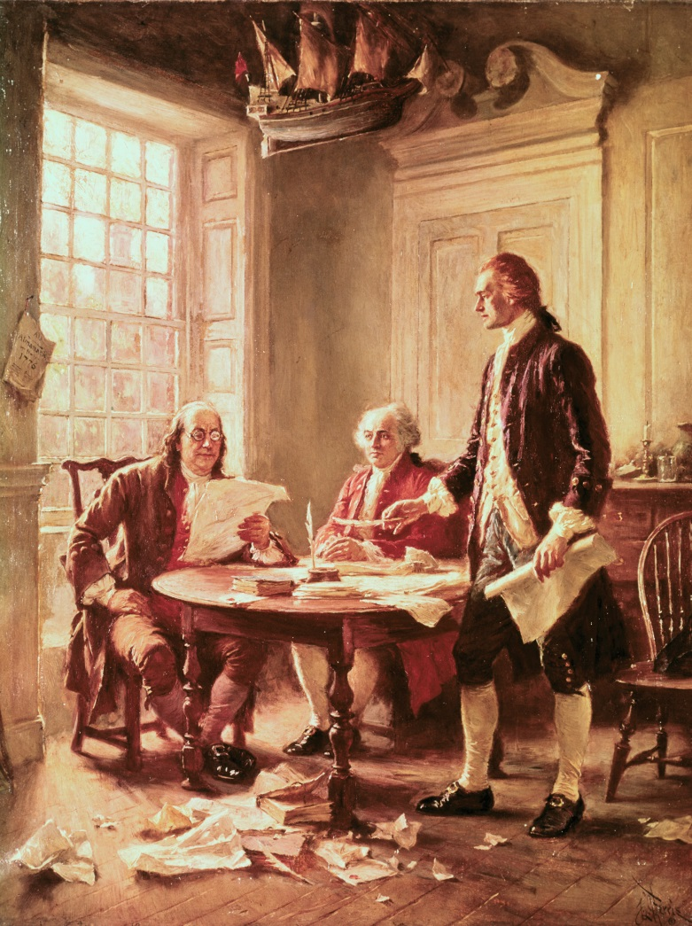
On June 7, Richard Henry Lee, from Virginia, presented a formal plan calling for the colonies to declare its independence from England. On June 11, Congress created a committee to draft a declaration of independence. Thomas Jefferson is chosen by the committee to prepare the first draft of the declaration, which he completed in one day. On June 28, Jefferson's Declaration of Independence is presented to the Congress. On July 4, the Congress formally supported Jefferson's Declaration, with copies sent to all of the colonies. The actual signing of the document occurred on August 2 with most of the 55 members of Congress placing their names on the document.

