Guide: How Iran is ruled

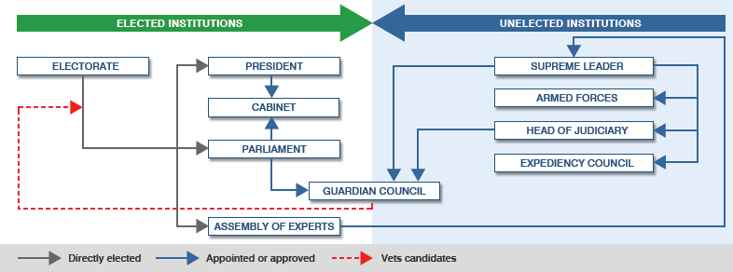

ELECTORATE
Of a total population of about 65 million, more than 46 million people - all those over 18 - are eligible to vote. Young people constitute a large part of the electorate with about 50% of voters being under 30.
Voter turnout hit a record high at 80% in the 1997 elections which delivered a landslide victory for reformist President Mohammad Khatami. Women and young people were key to the vote.
But with disillusionment growing, only about 60% of the electorate voted in the final round of the 2005 election which brought hardliner Mahmoud Ahmadinejad to power.
PRESIDENT
The president is elected for four years and can serve no more than two consecutive terms.
The constitution describes him as the second-highest ranking official in the country. He is head of the executive branch of power and is responsible for ensuring the constitution is implemented.
In practice, however, presidential powers are circumscribed by the clerics and conservatives in Iran's power structure, and by the authority of the Supreme Leader. It is the Supreme Leader, not the president, who controls the armed forces and makes decisions on security, defence and major foreign policy issues.
All presidential candidates are vetted by the Guardian Council, which banned hundreds of hopefuls from standing in the 2005 elections.
Conservative Tehran mayor Mahmoud Ahmadinejad became president in 2005 after he defeated former president Akbar Hashemi Rafsanjani in a second round run-off poll. Mr Ahmadinejad is Iran's first president since 1981 who is not a cleric.
Mr Ahmadinejad replaced reformist Mohammad Khatami who was elected president in May 1997 with nearly 70% of the vote. He failed to get key reforms through the Guardian Council and was hampered further after conservatives won back a majority in parliament in elections in 2004.
CABINET
Members of the cabinet, or Council of Ministers, are chosen by the president. They must be approved by parliament, which in 2005 rejected four of President Mahmoud Ahmadinejad's initial nominees for his hardline cabinet. Parliament can also impeach ministers.
The Supreme Leader is closely involved in defence, security and foreign policy, so his office also holds influence in decision-making. Reformist ministers under former President Khatami were heavily monitored by conservatives. The cabinet is chaired by the president or first vice-president, who is responsible for cabinet affairs.
PARLIAMENT
The 290 members of the Majlis, or parliament, are elected by popular vote every four years. The parliament has the power to introduce and pass laws, as well as to summon and impeach ministers or the president.
However, all Majlis bills have to be approved by the conservative Guardian Council.
The first reformist majority was elected in 2000, but this was overturned four years later in elections in 2004. Many reformist candidates were banned from standing.
The current speaker of the parliament is Ali Larijani, a former chief nuclear negotiator.
ASSEMBLY OF EXPERTS
The responsibilities of the Assembly of Experts are to appoint the Supreme Leader, monitor his performance and remove him if he is deemed incapable of fulfilling his duties. The assembly usually holds two sessions a year.
Although the body is officially based in the holy city of Qom, sessions are also held in Tehran and Mashhad. Direct elections for the 86 members of the current assembly are held every eight years and are next due in 2014.
Members are elected for an eight year term. Only clerics can join the assembly and candidates for election are vetted by the Guardian Council.
The assembly is dominated by conservatives. Its current chairman is former President Akbar Hashemi-Rafsanjani, who lost the 2005 presidential election to President Mahmoud Ahmadinejad.
GUARDIAN COUNCIL
This is the most influential body in Iran and is currently controlled by conservatives. It consists of six theologians appointed by the Supreme Leader and six jurists nominated by the judiciary and approved by parliament.
Members are elected for six years on a phased basis, so that half the membership changes every three years.
The council has to approve all bills passed by parliament and has the power to veto them if it considers them inconsistent with the constitution and Islamic law. The council can also bar candidates from standing in elections to parliament, the presidency and the Assembly of Experts.
Reformist attempts to reduce the council's vetting powers have proved unsuccessful and the council banned all but six of more than 1,000 hopefuls in the 2005 elections.
Two more, both reformists, were permitted to stand after the Supreme Leader intervened. All the female candidates were blocked from standing.
SUPREME LEADER
The role of Supreme Leader in the constitution is based on the ideas of Ayatollah Khomeini, who positioned the leader at the top of Iran's political power structure.
The Supreme Leader, currently Ayatollah Ali Khamenei, appoints the head of the judiciary, six of the members of the powerful Guardian Council, the commanders of all the armed forces, Friday prayer leaders and the head of radio and TV. He also confirms the president's election. The Leader is chosen by the clerics who make up the Assembly of Experts.
Periodic tension between the office of the Leader and the office of the president has often been the source of political instability. It increased during former president reformist Mohammad Khatami's term in office - a reflection of the deeper tensions between religious rule and the democratic aspirations of many Iranians.
HEAD OF JUDICIARY
The Iranian judiciary has never been independent of political influence. Until early last century it was controlled by the clergy. The system was later secularised, but after the revolution the Supreme Court revoked all previous laws that were deemed un-Islamic. New laws based on Sharia - law derived from Islamic texts and teachings - were introduced soon after.
The judiciary ensures that the Islamic laws are enforced and defines legal policy. It also nominates the six lay members of the Guardian Council. The head of the judiciary, currently Ayatollah Mahmoud Hashemi Shahrudi, is appointed by, and reports to, the Supreme Leader.
In recent years, the hardliners have used the judicial system to undermine reforms by imprisoning reformist personalities and journalists and closing down reformist papers.
ARMED FORCES
The armed forces comprise the Revolutionary Guard and the regular forces. The two bodies are under a joint general command.
All leading army and Revolutionary Guard commanders are appointed by the Supreme Leader and are answerable only to him.
The Revolutionary Guard was formed after the revolution to protect the new leaders and institutions and to fight those opposing the revolution.
The Revolutionary Guard has a powerful presence in other institutions, and controls volunteer militias with branches in every town.
EXPEDIENCY COUNCIL
The Council is an advisory body for the Leader with an ultimate adjudicating power in disputes over legislation between the parliament and the Guardian Council. The Supreme Leader appoints its members, who are prominent religious, social and political figures.
In October 2005, the Supreme Leader gave the Expediency Council "supervisory" powers over all branches of government - delegating some of his own authority as is permitted in the constitution.
It is not clear exactly how much this will affect the Council's influence, although observers say it is likely to strengthen the position of its present chairman, former President Hashemi Rafsanjani, who was defeated in the 2005 presidential elections by Mahmoud Amadinejad.
Story from BBC NEWS:
http://news.bbc.co.uk/go/pr/fr/-/2/hi/middle_east/8051750.stm
Published: 2009/06/09 09:42:51 GMT
© BBC 2019

