APCOGO/Spring 2017
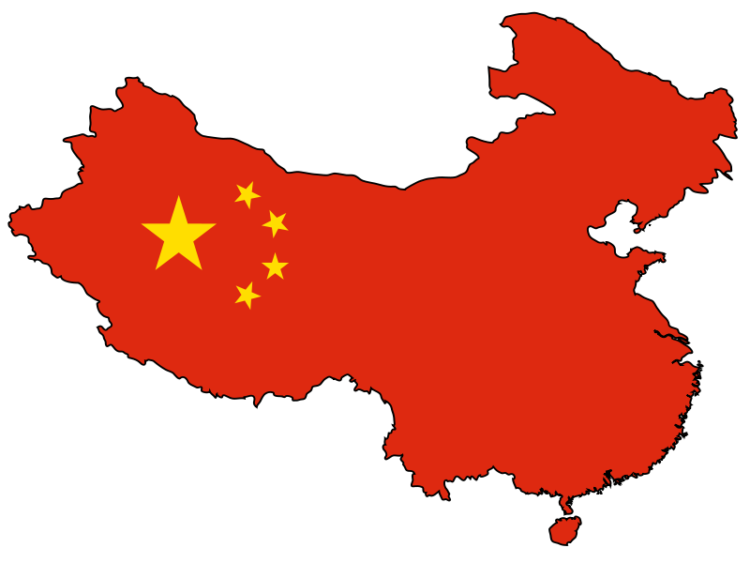
Unit 5: China

China Mini-Presentation Topics

Directions: You and your partners should choose ONE of the following topics to research and present to the class during the course of this unit. Prepare a brief (5-7 minute) presentation (see rubric on back). Limit your text to key points and provide pictures/graphics to enhance your presentation. You may use Powerpoint, Prezi, or any other presentation software.

TOPICS:

- China’s Relations/Policies toward Hong Kong and Taiwan (Mon 3/27)
  - Historic/Current

- China’s Communist Party General Secretary/President of China Xi Jinping (Mon. 3/27)
  - Background and expected policies/vision for China

- China’s Judicial/Legal System (Mon 3/27)
  - Include burden of proof, conviction rate, death penalty crimes

- China’s Market Economy and Tension with Communism (Tues 3/28)
  - Historic/Current

- China’s Relations/Policies Toward Ethnic Groups and Tibet (Tues.3/28)
  - Identify major ethnic groups/current policy
- China’s Relations/Policies toward Falun Gong and other Reform Groups (Tues. 3/28)
  - Explain what Falun Gong is and why China has reacted negatively to it

- The Role of Women in Chinese Society and Politics (Wed. 3/29)
  - How has communism shaped the role of women in society/politics?

- China’s Population Challenges (Wed. 3/29)
  - Two-child policy (reason for policy, enforcement, current status), rural/urban population shift, aging population

China Mini-Presentations Rubric

Presentation includes all key points related to topic _____/20 points

Text is limited to key points and not overly wordy _____/5 points

Presentation includes visuals (pictures/graphics) _____/5 points

All presenters are knowledgeable about topic & add _____/20 points information beyond what is typed in presentation

TOTAL: _____/50 points

